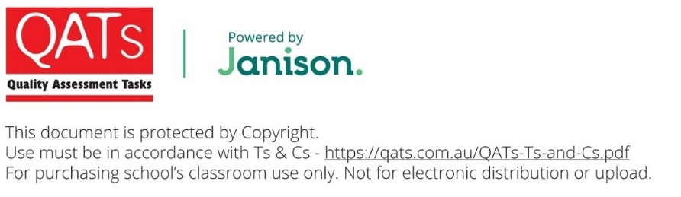
NAME: ____________________________
VCE® SPECIALIST MATHEMATICS
Units 3 & 4 Practice Written Examination 2
Reading time: 15 minutes
Writing time: 2 hours
QUESTION AND ANSWER BOOK
Structure of book
Section | Number of questions | Number of questions to be answered | Number of marks
A | 20 | 20 | 20
B | 6 | 6 | 60
 |  |  | Total 80

- Students are permitted to bring into the examination room: pens, pencils, highlighters, erasers, sharpeners, rulers, a protractor, set-squares, aids for curve sketching, one bound reference, one approved technology (calculator or software) and, if desired, one scientific calculator. Calculator memory DOES NOT need to be cleared. For approved computer-based CAS, full functionality may be used.
- Students are NOT permitted to bring into the examination room: blank sheets of paper and/or correction fluid/tape.
Materials supplied
- Question and answer book of 30 pages.
- Formula sheet.
- Answer sheet for multiple-choice questions.
Instructions
- Write your name in the space provided above on this page.
- Write your name on the multiple-choice answer sheet.
- Unless otherwise indicated, the diagrams are not drawn to scale.
- All written responses must be in English.

Students are NOT permitted to bring mobile phones and/or any other unauthorised electronic devices into the examination room.
SECTION A – Multiple-Choice Questions
Instructions for Section A
Answer all questions in pencil on the answer sheet provided for Multiple-Choice Questions.
Choose the response that is correct for the question.
A correct answer scores 1; an incorrect answer scores 0.
Marks will not be deducted for incorrect answers.
No marks will be given if more than one answer is completed for any question.
Unless otherwise indicated, the diagrams in this book are not drawn to scale.
Take the acceleration due to gravity to have magnitude g ms⁻², where .
Question 1
Consider the following statements:
P: is even. Q: n is odd.
Which one of the following statements would be assumed in order to prove the conjecture
If is even then n is odd
using proof by contradiction?
A.
B.
C.
D.

Question 2
Two of the asymptotes of the graph of are given by and .
Possible values of a, b and c are, respectively
A. | , ,
B. | , , 3
C. | , ,
D. | , , 3
Question 3
The graph of , where , will have no x-intercept only when
A.
B.
C. | and
D. | and

Question 4
The complex numbers , and , where , are plotted in the Argand plane to form the vertices of a triangle.
The area of this triangle is given by
A.
B.
C.
D.
Question 5
If and , then is equal to
A.
B.
C.
D.

Question 6
The relation , where and , will define a ray when
A.
B.
C.
D.
Question 7
Consider the following pseudocode.
define f(t,x)
return (t^2+1)/(x^3+1)
a ← b
b ← 4
n ← 10
h ← (b-a)/n
t ← a
x ← 3
for i from 1 to n
x ← x + h*f(t,x)
t ← t+h
end for
print x to three decimal places
For which one of the following values of a will the pseudocode print 3.504?
A. | 2.1
B. | 2.2
C. | 2.3
D. | 2.4

Question 8
A tank initially contains 16 kg of salt that is dissolved in 90 L of water. A solution containing 6 kg of salt per litre of water flows into the tank at a rate of 5 L per minute and the mixture in the tank is kept well stirred. At the same time, 7 L of the mixture flows out of the tank per minute.
A differential equation defining the concentration, c kg per litre of water, of salt in the tank at time t minutes, for a non-zero volume of mixture, is
A.
B.
C.
D.
Question 9
The position vector of a particle moving in the Cartesian plane, at time t, is given by
, where .
What is the slope of the tangent to the path of the particle when ?
A.
B.
C.
D.

Question 10
For n a nonnegative integer, let . If , then equals
A.
B.
C.
D.
Question 11
The area of the surface generated by rotating the curve with equation about the line from the points where to equals
A.
B.
C.
D.

Question 12
Consider the vectors and such that , and .
Then equals
A.
B. | 5
C.
D.
Question 13
Consider the vectors and such that and . The angle between and , correct to the nearest degree, is
A. | 50
B. | 55
C. | 60
D. | 65
Question 14
A particle starts from rest and moves in a straight line. The velocity, v, of the particle after t seconds is , where x meters is the distance the particle has moved.
If the particle moves 2 metres in 3 seconds, the time it takes to move 5 metres is approximately
A. | 1.52 seconds
B. | 2.36 seconds
C. | 3.52 seconds
D. | 5.36 seconds

Question 15
An object with an initial velocity of 6 moves in a straight line with constant acceleration. After ten seconds it is moving at 8 in the opposite direction to its initial velocity.
The distance, in metres, of the object from its starting point after twelve seconds is
A. | 28.8
B. | 57.6
C. | 68.6
D. | 86.4

Question 16
A supply aircraft is to release a package so that it lands at a drop position, as shown in the diagram below.
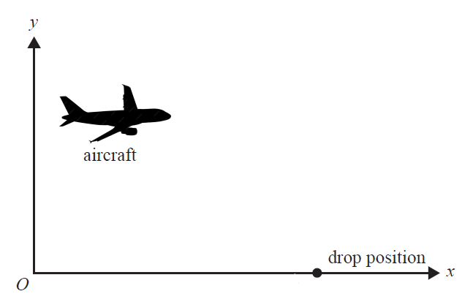
1550 m
The position vector of the supply aircraft relative to a fixed observation point O is
, seconds.
The drop position is located 1550 m horizontally from O. is a horizontal unit vector in the direction of the drop position and is a unit vector vertically up. Displacement components are measured in metres.
When the aircraft is at a height of 540 m, it releases the package. Assuming negligible air resistance acting on the package, how far short of the drop position, correct to the nearest meter, does the package land?
A. | 36
B. | 40
C. | 44
D. | 48

Question 17
The planes
, ,
intersect along a common line when
A. | and
B.
C.
D.
Question 18
If the vector is perpendicular to the lines and , then
A. | , ,
B. | , ,
C. | , ,
D. | , ,

Question 19
Consider a random variable X with probability density function
.
If a large number of samples, each of size 80, is taken from this distribution, then the distribution of sample means, , is approximately normal with a standard deviation of
A.
B.
C.
D.
Question 20
The lifespan of a certain type of lightbulb is normally distributed with a mean of hours and a standard deviation of 420 hours.
A random sample of these lightbulbs is collected and used to calculate an approximate 90% confidence interval for . If the confidence interval is (14 428, 14 572) then the sample size is
A. | 92
B. | 90
C. | 88
D. | 86
END OF SECTION A
SECTION B
Instructions for Section B
Answer all questions in the spaces provided.
Unless otherwise specified, an exact answer is required to a question.
In questions where more than one mark is available, appropriate working must be shown.
Unless otherwise indicated, the diagrams in this book are not drawn to scale.
Take the acceleration due to gravity to have magnitude g , where .
Question 1 (10 marks)
Consider the function f with rule where
- State the equations of all potential asymptotes of f. 2 marks

- Verify that f is not smooth at the point where except when a has one particular value, which you should state. 3 marks

- Sketch the graph of on the axes below when and . Label asymptotes with their equations, and label axis intercepts with their coordinates. 3 marks
- Consider the function g with rule for .
Find the values of k for which the graph of has three x-intercepts. Give answers correct to four decimal places if an exact answer is not possible. 2 marks

Question 2 (12 marks)
Let .
- Express S in cartesian form. 1 mark

- Find the larger of the two areas bounded by S and . 2 marks

- All except one of the elements of S are elements of where
Find the values of a and b. 2 marks

- Prove that all except one of the elements of S are elements of 2 marks

- Sketch on the Argand diagram below. 3 marks
Im(z)
- Let . Find the values of . 2 marks
Re(z)

Question 3 (9 marks)
Consider the curve given by
- The area bounded by the curve and the x-axis over the interval is rotated about the x-axis to form a solid of revolution.
Find, correct to four decimal places, the volume of this solid. 2 marks

- Find the area of the surface formed when the part of the curve over the interval is rotated about the y-axis. Give your answer correct to four decimal places. 3 marks

- Find the arclength of the curve over the interval . Give your answer correct to four decimal places. 2 marks

Consider the curves and where over the interval and
Let L be the arclength of over
Let and be the respective areas of the surface formed when the part of each curve and over the interval is rotated about the x-axis.
- Express in terms of and L. 2 marks

Question 4 (10 marks)
At the start of the year 2024 the Gratuitous Fish Farm releases 150 fish into a pond that originally contained no fish. Fish are removed from the pond at the end of each year.
The fish population, N, grows according to the model:
where t is the number of years after the release of the 150 fish and n is the number of fish removed at the end of each year.
- Find the value(s) of n for which the rate at which the fish population initially grows is positive. 1 mark

- Find the value(s) of n such that the solution to has the form:
where 2 marks

- Find, correct to the nearest integer, the value of n such that there are no fish in the pond after four years. 2 marks

Suppose .
- Without solving the differential equation:
    - Given that the graph of has a point of inflection, find the N - coordinate of this point. 2 marks

    - Briefly explain why N has a limiting value and find this value, correct to the nearest integer. 2 marks

- Find, in years, the value of t when . Give your answer correct to two decimal places. 1 mark

Question 5 (10 marks)
Let the vectors and .
- Show that and are perpendicular to each other. 1 mark

A plane, , contains the point and the vectors and are parallel to.
- Find a cartesian equation of . 2 marks

The position vector of an object is given by
,
where time t is measured in minutes and distance is measured in decametres.
- Show that contains the path followed by the object. 2 marks

- Find the distance travelled by the object after one minute. Give your answer in decametres correct to four decimal places. 2 marks

The position vector of a second object is given by
,
where time t is measured in minutes and distance is measured in decametres.
- Find a cartesian equation of the path followed by the second object. 1 mark

- Find, in decametres, the minimum distance of the second object from .
Give your answer in the form where 2 marks

Question 6 (9 marks)
Gilne Garden Supplies sells large and small bags of manure. It is known that the amount of manure in a small bag is normally distributed with a standard deviation of 0.75 kg.
- The probability that the combined amount of manure in three small bags is more than 46 kg is approximately 0.6238.
Use an appropriate value of the standard normal random variable Z to find the mean amount of manure in a small bag. Give your answer in kg correct to two decimal places. 3 marks

It is known that the amount of manure in a large bag is normally distributed with a standard deviation of 1 kg. The mean amount of manure in a large bag is advertised to be 25 kg.
Stefan is the manure manager. He thinks that the true mean amount of manure in a large bag is not 25 kg and decides to apply a statistical test at the 3% level of significance.
- Write down the null hypothesis, , the alternative hypothesis, , and the probability of a type I error for the test. 1 mark

Stefan takes a random sample of 32 large bags and finds that the total amount of manure is 807.4 kg.
- Find the p value for the test correct to four decimal places. 2 marks

Suppose that the true mean amount of manure in a large bag is 25.6 kg.
- Calculate the probability, correct to three decimal places, of Stefan making a type II error in the statistical test. 3 marks

END OF EXAMINATION
Multiple-Choice Answer Sheet
Student Name:
Shade the letter that corresponds to each correct answer.
Question | A | B | C | D
Question 1 | [ ] | [ ] | [ ] | [ ]
Question 2 | [ ] | [ ] | [ ] | [ ]
Question 3 | [ ] | [ ] | [ ] | [ ]
Question 4 | [ ] | [ ] | [ ] | [ ]
Question 5 | [ ] | [ ] | [ ] | [ ]
Question 6 | [ ] | [ ] | [ ] | [ ]
Question 7 | [ ] | [ ] | [ ] | [ ]
Question 8 | [ ] | [ ] | [ ] | [ ]
Question 9 | [ ] | [ ] | [ ] | [ ]
Question 10 | [ ] | [ ] | [ ] | [ ]
Question 11 | [ ] | [ ] | [ ] | [ ]
Question 12 | [ ] | [ ] | [ ] | [ ]
Question 13 | [ ] | [ ] | [ ] | [ ]
Question 14 | [ ] | [ ] | [ ] | [ ]
Question 15 | [ ] | [ ] | [ ] | [ ]
Question 16 | [ ] | [ ] | [ ] | [ ]
Question 17 | [ ] | [ ] | [ ] | [ ]
Question 18 | [ ] | [ ] | [ ] | [ ]
Question 19 | [ ] | [ ] | [ ] | [ ]
Question 20 | [ ] | [ ] | [ ] | [ ]

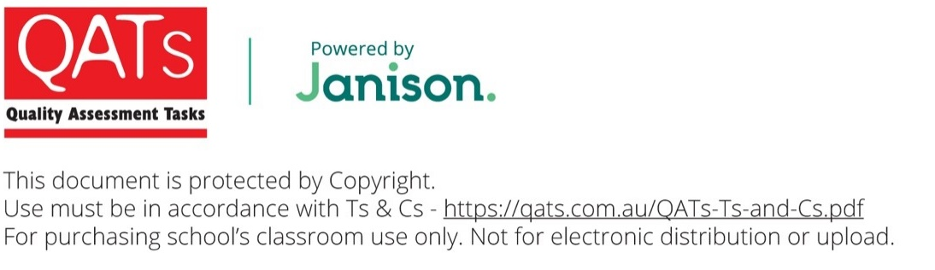
VCE® Specialist Mathematics
Practice Written Examination 2
ADVICE FOR TEACHERS
Teachers should provide students with a copy of the VCAA formula sheet.
The VCAA formula sheet can be downloaded and printed from
https://www.vcaa.vic.edu.au/assessment/vce-assessment/past-examinations/Pages/Specialist-Mathematics.aspx
IMPORTANT SECURITY ADVICE FOR EXAMINATION TASKS
By ordering and using QATs materials from Janison you are agreeing to the Terms and Conditions of sale, found at qats.com.au/QATs-Ts-and-Cs
Storage
This resource is protected by Copyright and sold on the condition that it is not placed on any school network, student management system or social media site (such as Facebook, Google Drive, OneDrive, etc) at any time. It should be stored on a local device drive of the teacher who made the purchase.
Purchaser Use
This resource is for use in the purchasing school or institution only. STRICTLY NOT FOR PRIVATE TUTOR USE. You may not make copies, sell, lend, borrow, upload, or distribute any of the contents within the QATS product or produce, transmit, communicate, adapt, distribute, license, sell, modify, publish, or otherwise use, any part of the QATs product without our permission or as permitted under our Terms and Conditions.
Embargo
Students must not take their Examination Assessment Tasks home/out of the classroom until the end of the embargoed period. This is to ensure the integrity of the task. In NSW, this period is mandated by QATs. In VIC, QLD and SA this period may be determined by individual schools based on specific school requirements. Teachers may go through papers and results with students in class during this period; however, papers must be collected and kept by the teacher at the end of the lesson (or similar). When the embargoed period has ended, assessments may be permanently returned to students.
Compliance and Task Editing
This task has been developed to be compliant with VCAA assessment requirements, however, QATs does not guarantee or warrant compliance.
It may be necessary to edit or change this task for security or compliance purposes. Permission is provided to do this for internal school purposes only. If so, care should be taken to maintain the quality of the material concerning its design and layout, including such elements as marking schemes, pagination, cross-referencing, and so on. QATs assumes no responsibility for the integrity of the task once it is changed. If you edit this task you must:
- Remove the QATs and Janison logos and all other references to QATs and Janison.
- Select and copy ‘Task’ pages ONLY into a new document. These are the only pages students will require to complete their assessment. Save with a school-/class-specific file/subject/outcome name. Do not use the QATs file code.
- Remove all footer information from all pages. The page 1 footer of QATs is usually set up differently from other pages. Insert your own footer information for your reference.
- Remove all QATs header references from all pages.
- Insert your school logo/identification on page 1 and other pages at your discretion.
Unless otherwise indicated and to the best of our knowledge, all copyright in the QATS product is owned by or licensed to Janison Solutions Pty Ltd (ABN 35 081 797 494) trading as QATS. If you reasonably believe that any content in our QATS product infringes on anyone’s intellectual property rights or is the owner of the copyright and would like to request removal of the content, please email qatsadmin@janison.com
Solution Pathway
Below are sample answers and solutions. Please consider the merit of alternative responses.
Specialist Mathematics Examination 2: Marking Scheme
SECTION A: Multiple-Choice Questions – Answers
1. | C | 5. | C | 9. | A | 13. | C | 17. | C
2. | B | 6. | D | 10. | B | 14. | D | 18. | D
3. | A | 7. | D | 11. | C | 15. | A | 19. | C
4. | D | 8. | B | 12. | D | 16. | B | 20. | A
SECTION A: Multiple-Choice Questions – Solutions
Q 1 | To prove that if , it is assumed for the sake of contradiction that | C

Q 2 | - is a vertical asymptote therefore is a root of :  …. (1)  - Let and  From a CAS:  Therefore has an oblique asymptote  - Case 1: :  therefore is a diagonal asymptote of .  Compare with :  .  Substitute and into (1): . No corresponding option.  - Case 2: :  therefore is a diagonal asymptote of  Compare with :  .  Substitute and into (1): . Option B.  Discussion of Case 2:  It follows that ,  Therefore has a ‘hole’ at . | B

Q 3 | Horizontal asymptotes: and .  It is therefore required that either:  Case 1: and therefore and  or  Case 2: and therefore and  Both cases are equivalent to | A
Q 4 | The geometric interpretation of is the rotation of by in a clockwise direction. Therefore the area of the triangle is half the area of a square whose vertices are at 0, , , :  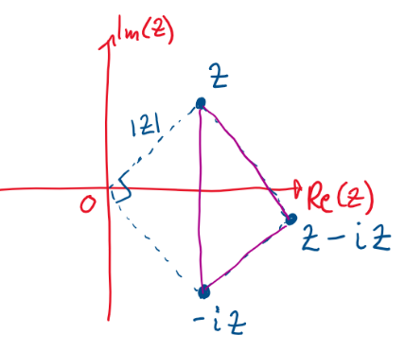  By inspection the length of a side of the square is therefore the area of the square is therefore the area of the triangle is . | D

Q 5 | Let , .  The rays , and intersect at the point where :  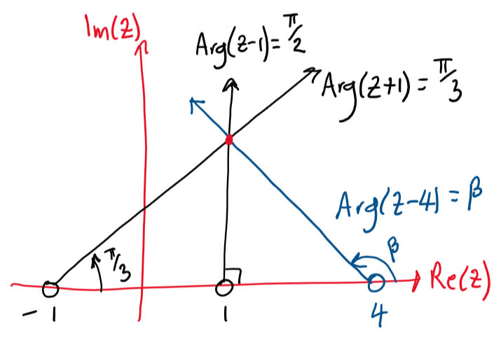  The cartesian equation of is ,  Substitute :  Therefore the rays , and intersect at  Substitute into : | C

Q 6 | a is real therefore and lie on the real axis.  Geometric interpretation:  is the distance of z from , is the distance of z from  The distance between and is  Let where . Let :  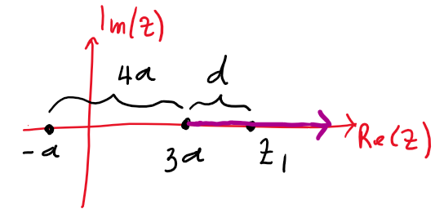  Then  Therefore defines a ray.  Discussion: By inspection, the equation of the ray is , . The terminus of the ray has coordinates and is included as part of the ray.  Algebraic calculation:  Substitute , , into :  Note the implied restriction:  RHS therefore LHS  ,  If then a ray is obtained: ,  If : and there is no solution since  LHS and RHS | D
Q 7 | The pseudocode applies Euler’s method to find an approximate solution to the differential equation given that and  The number of iterations is therefore , the value of the step size is and (output correct to three decimal places).  Substitute the value of a in each option into the above data and execute Euler’s Method on a CAS. | D

Q 8 | (rate at which salt enters the tank) − (rate at which salt leaves the tank).  - Rate at which salt enters the tank  = (rate of inflow) (concentration of salt in inflow)  = (5 litres per minute) (6 kg per litre) = 30 kg per minute.  - Rate at which salt leaves the tank  = (rate of outflow) (concentration of salt in outflow)  = (7 litres per minute) (concentration of salt in outflow).  - After t minutes have elapsed: Concentration of salt in outflow  where V is the volume of solution in the tank after t minutes:  (initial volume) + (volume added after t minutes via inflow)  − (volume removed after t minutes via outflow)  = 90 litres + 5t litres − 7t litres litres.  Therefore: concentration of salt in outflow kg per litre.  Therefore rate at which salt leaves the tank  = (7 litres per minute) (concentration of salt in outflow)  kg per minute  (rate at which salt enters the tank) − (rate at which salt leaves the tank) | B

      - Differential equation for the concentration c of salt in the tank at time t:
Substitute :
Q 9 | The value of at is required.  When : , .  Use a CAS to get the values of and when :  when | A

Q 10 | Consider and use integration by parts:  Let  Let | B
 | ()

Q 11 | The area of the surface generated by rotating the curve with equation about the line from the points where to is equal to the surface generated by rotating the curve with equation about the y-axis from the points where to .  Area of the surface generated by rotating the curve $y=f(x)$ about the y-axis:  . | C

Q 12 | The vectors and form a parallelogram with pairs of opposite sides of length and and diagonals of length and :  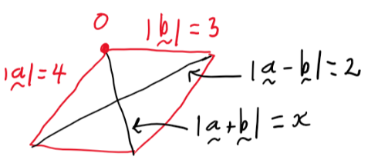  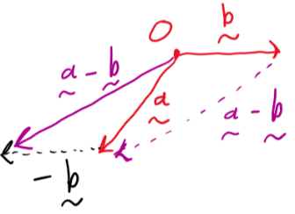  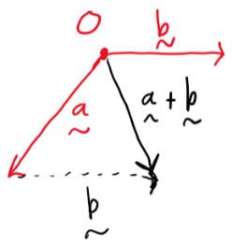  For the parallelogram with pairs of opposite sides of length a and b and diagonals of length p and q: . | D
 | 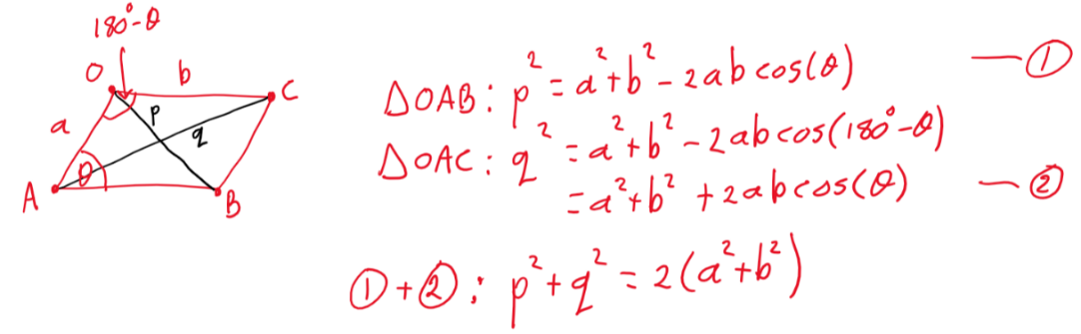
Q 13 | Let the angle between and be :  . …. (1)  . …. (2)  : | C
Q 14 | and when .  The integral solution must be used: .  Substitute : | D
Q 15 | The acceleration of the object is constant therefore the straight line motion formulae for constant acceleration can be used:  Motion after 10 seconds:  Data: , , seconds,  Motion after 12 seconds:  Data: , seconds, ,  m  Therefore the distance is 28.8 metres. | A

Q 16 | - Time at which the aircraft drops the package: seconds.  - Initial conditions for the motion of the package:  ,  Method 1:  - Solve (since the air resistance acting on the package is negligible) subject to the above initial conditions (either using a CAS or ‘by hand’):  Therefore and  - Time at which the package lands:  (and )  - Horizontal distance of package from O:  m  Method 2:  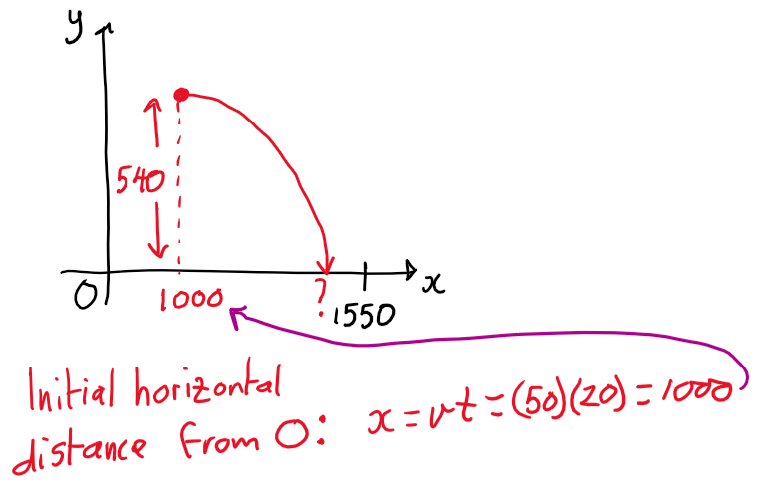  - Acceleration of the package is constant therefore the straight line motion formulae for constant acceleration can be used:  Horizontal motion (): Vertical motion ():  , , , m  ,  - Therefore horizontal distance of package from O  - Therefore distance short of the drop position  m | B
Q 17 | - Determine the value(s) of k for which the planes  , ,  do not intersect at a unique point:  det  - Test each solution.  : , ,  Solve simultaneously (use a CAS):  Infinite number of solutions which corresponds to a line.  : , ,  Solve simultaneously (use a CAS): No solution. | C

Q 18 | - , , ,  Therefore a vector in the direction of the line is  - , , ,  Therefore a vector in the direction of the line is  - Therefore a vector normal to each line is (use a CAS) is  - Therefore  Equate -components:  Equate -components:  Equate -components: | D
Q 19 | - . | C

Q 20 | Method 1:  Use a CAS to check the confidence interval arising from the value of n in each option: .  Method 2:  …. (1)  …. (2)  For a 90% confidence interval: (use a CAS).  Substitute , and into either equation (1) or equation (2) and solve for n (use a CAS and round to the nearest integer):  . | A

SECTION B: Solutions
Question 1
Part a.:
Note: These are only potential asymptotes because the asymptotic behaviour of f depends on the values of a and b. Some of these asymptotes do not exist for particular values of a and b (for example, f has no asymptotes when and ).
- Potential vertical asymptote:
- Asymptotic behaviour as :
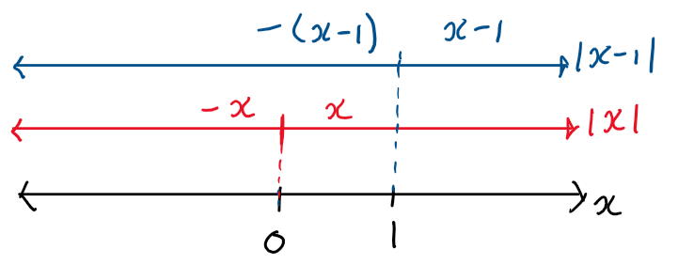
To consider it is therefore necessary to get the rule for when :
:
To consider it is therefore necessary to get the rule for when :
:
Three correct potential asymptotes:  , ,  Do not accept in place of and (because is sometimes a diagonal asymptote when is not, and vice versa). | 2 marks
Two correct potential asymptotes. | 1 mark
One or no correct potential asymptotes. | 0 marks
Part b.:
For f to be ‘smooth’ at it is necessary and sufficient that is continuous at
It is therefore necessary and sufficient that:
1. exists. 2.
1. Existence of
From a CAS:
and
and | 1 mark
2. and . It must now be checked that
and therefore
From a CAS:
Therefore not ‘smooth’ at the point where unless | 1 mark
Part c.:
Answer:
Shape:  There must be a ‘corner’ at the y-intercept.  The turning point in the interval must be lower than the turning point in the interval . | 1 mark
Asymptotes: , , . | 1 mark
Axis intercepts: , , , , . | 1 mark
Calculations:
      - Asymptotes are found from Part a.
Vertical asymptote:
Diagonal asymptotes: Substitute into into and
- Axis intercepts:
y-intercept: Substitute x-intercepts: Use a CAS to solve
- Shape: From Part b. the graph is not smooth at (that is, the y-intercept) because . Therefore there is a ‘corner’ at
Part d.:
- Consider the graphs of and
It is required to find the values of k for which these graphs have three intersection points
The value of k controls the vertical translation of :
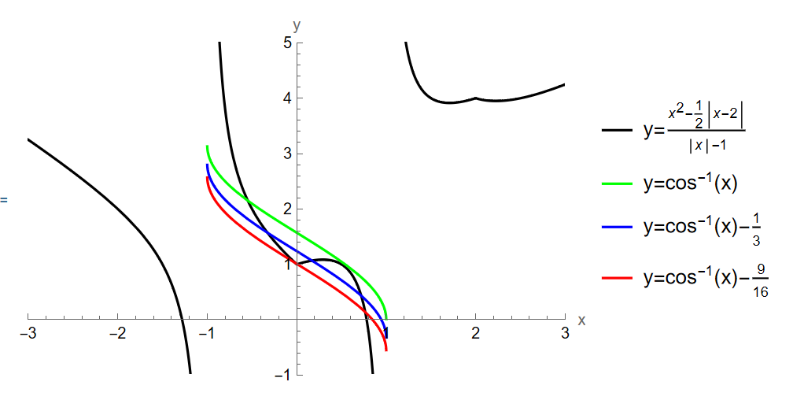
Minimum value of k:
By inspection the value of k needs to be greater than the value of k such that point of inflection of coincides with the ‘corner’ of
at (1, 0).
It is therefore required that the y-coordinate of the point of inflection of is equal to 1:
:

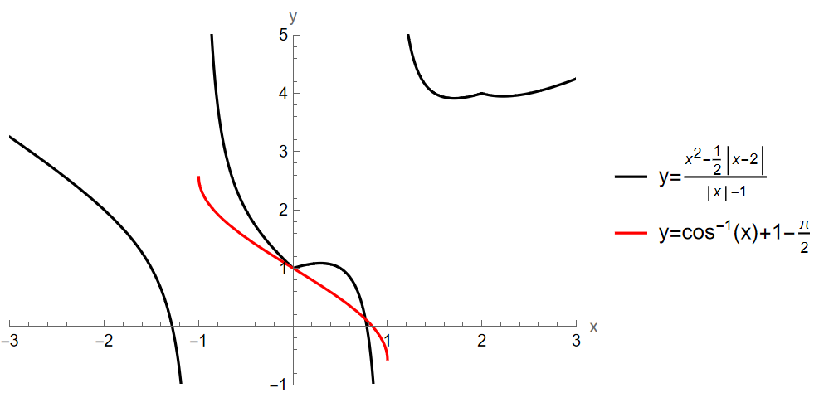
Maximum value of k:
By inspection there is some value such that and have a common tangent in the interval
There are therefore three intersection points when
for
Let at the point of common tangency. It is required that
…. (1)
…. (2)
and
Use a CAS to solve equations (1) and (2) simultaneously for :
Note:
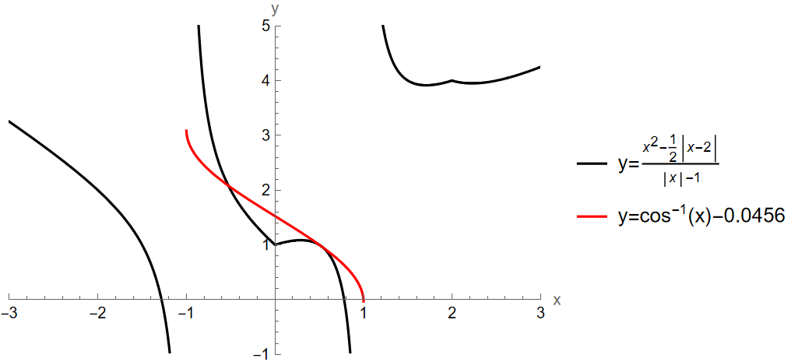
.  Note:  The correct maximum value of k, rounded to four decimal places, is and should be accepted (rounding UP is required).  This is because is above on the interval | 2 marks:  1 mark for the minimum value of k.  1 mark for the maximum value of k.

Question 2
Part a.:
is a circle with radius and centre at :
Answer: | 1 mark
Part b.:
- is the perpendicular bisector of the line segment joining and :
- Solve and simultaneously to get coordinates of intersection points:
Answer: and | 1 mark
Required area:
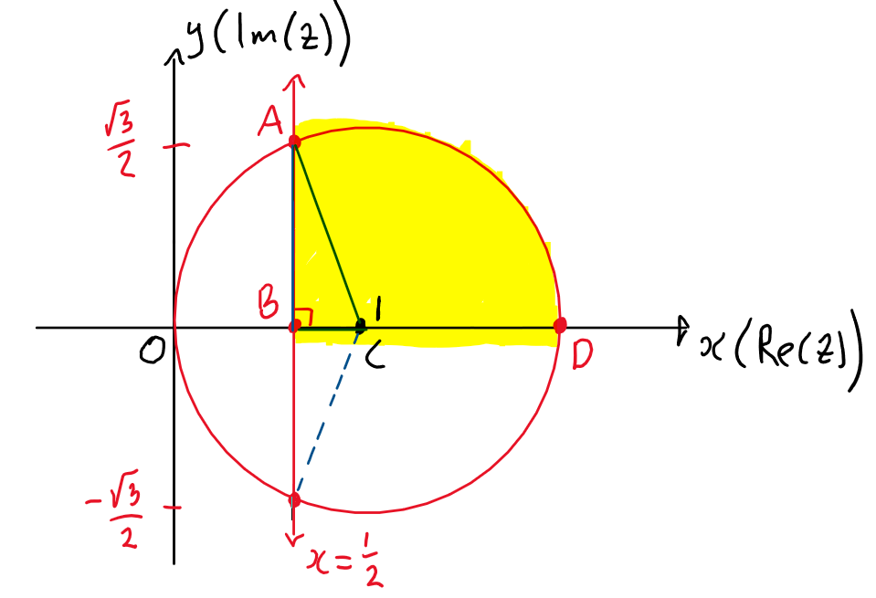

- Area of sector:
Area of sector
Area of sector | 1 mark
- Area of triangle
- Required area
Answer:  Accept | 1 mark

Part c.:
- is the exceptional element of that is not an element of
      - All elements are elements of
Therefore substitute two convenient elements of (use the answer to Part a.). For example:
: …. (1)
: …. (2)
Use a CAS to solve equations (1) and (2) simultaneously under the restriction :
and .
Note: The very convenient value does not give an equation that allows the unique solution for a and b.
Clear and valid method | 1 mark
Answer: and | 1 mark

Part d.:
for
Note:
- as and is not defined.
- since
- is the exceptional element of S that is not an element of
(because is not defined).
Case 1: and (upper half of the circle).
Let and :
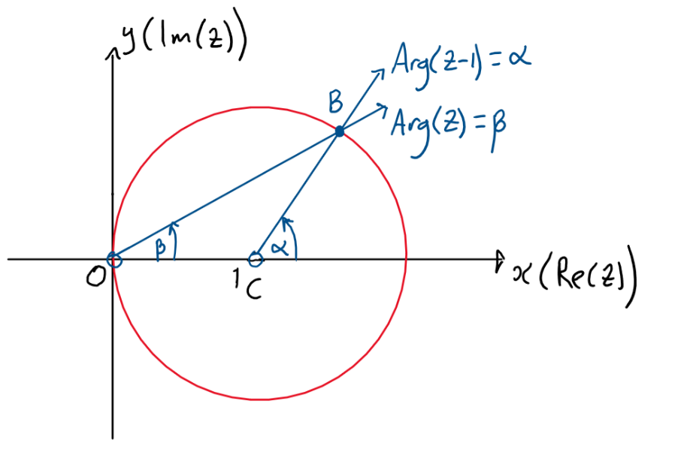
Proving is equivalent to proving :
(radius of circle)
therefore is isosceles
therefore
therefore . …. (1)
But . …. (2)
From equations (1) and (2): ■
Case 2: and (lower half of the circle).
The proof is identical to Case 1 by symmetry.
since  is the exceptional element of S that is not an element of | 1 mark
Appropriate labelled diagram.  Geometric proof. | 1 mark

Part e.:
Answer:
Shape: Circle with ‘hole’ at | 1 mark
Shape: Ray with terminus at | 1 mark
‘Hole’ at terminus of ray. | 1 mark
Calculations:
Shape:
- From part d. it is known that the circle , , is part of the solution.
- From part d. it is seen that and are equal when z is real and
()
Alternatively, when can be seen by inspection. If z is real:
therefore
therefore therefore
therefore therefore
is not defined for therefore is not a solution to
Part f.:
Let and where (from Part d.).
since and for S
provided
Then
Recognition that provided | 1 mark
Answer: | 1 mark
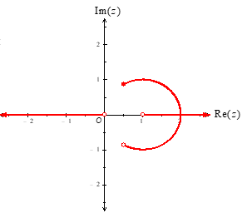
Discussion:
Sketch of :
Calculations:
- It is known that the circle is part of the solution for
- It is seen by inspection that and are equal when z is real and and :
or
Note: If z is real:
therefore
- therefore therefore
- therefore therefore
- therefore therefore
Question 3
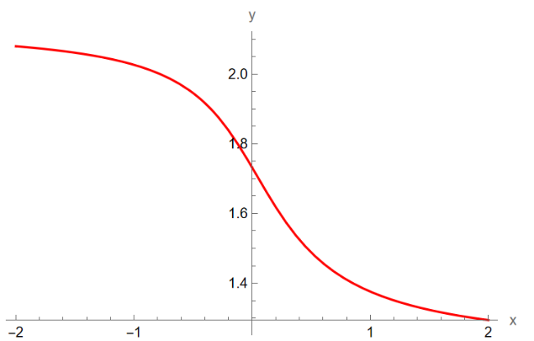
Part a.:
1 mark

Answer: 7.2106 cubic units | 1 mark

Part b.:
Integral terminals:
- . Accept | 1 mark

or  Accept , etc | 1 mark  Order of terminals must be correct.
- Substitute :
Answer: 3.2253 square units. | 1 mark
Part c.:
1 mark

Answer: 2.1233 units. | 1 mark

Part d.:
Use :
1 mark
Answer: | 1 mark
Question 4
Part a.:
Require at , that is, when :
Answer: | 1 mark

Part b.:
Require to be a perfect square. | 1 mark
Therefore .
Answer: | 1 mark
Check (use a CAS):
Solve with initial condition :
.
Observation: when .

Part c.:
Use a CAS to solve with initial condition :
Note: Different CAS may give different but equivalent forms.
Substitute and solve for n (round to the nearest integer):
1 mark

Answer: | 1 mark
Check (use a CAS):
- Solve with initial condition
- Substitute and solve for t:

Part d. i.:
with initial condition
Phase diagram (plot of versus N):
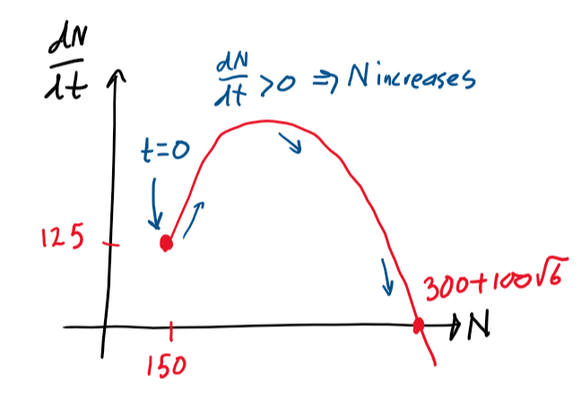
at () therefore N initially increases.
as N increases () therefore N continues to increase.
as .
Valid explanation that refers to a phase diagram. | 1 mark

Answer: 545 | 1 mark
Check (use a CAS):
- Solve with initial condition
- Calculate :
Part d. ii.:
has a turning point at therefore there is a point of inflection at
Answer: | 1 mark
Check (use a CAS):
- Solve with initial condition
- Solve for t:
- Substitute into N:
Part e.:
- Use a CAS to solve with initial condition
- Substitute and solve for t (round to two decimal places):
Answer: | 1 mark

Question 5
Part a.:
If and are normal to each other then :
1 mark
Explicit calculation is required.
Part b.:
Method 1:
- A cartesian equation of the plane is where is a vector normal to the plane.
A normal vector to the plane is . From a CAS or ‘by hand’:
Normal vector: | 1 mark
- Therefore
Substitute the point into and solve for d:
Therefore
- Explicit solution for d using the point  - Answer: | 1 mark  Accept all equivalent answers.

Method 2:
- is a point contained in the plane and the vectors and are parallel to
Therefore a vector equation of is where and
Therefore a set of parametric equations defining is
…. (1)  …. (2)  …. (3) | 1 mark
- Use a CAS to solve equations (1), (2) and (3) simultaneously for , and one of either x, y or z and simplify the ‘cartesian’ solution.
(This is equivalent to solving two of the equations simultaneously for and in terms of x, y and z and then substituting those solutions into the third equation).
Answer: | 1 mark

Part c.:
From the answer to Part b., it is noted that the point is contained in the plane .
The vectors and are parallel to .
Therefore a vector equation of is
where and | 1 mark  - Symbols different to and must be used in the vector equation.  - Parameters must be explicitly defined.
Note:
- A symbol different to must be used in the vector equation of because is the position vector of the object.
- A symbol different to t (such as ) must be used to represent a parameter in the vector equation of because t represents time in the position vector of the object.
Choosing and in defines the position vector of the object.  Therefore the points on the path followed by the object are a subset of the points contained in the plane. | 1 mark

Part d.:
- (from part c.).
- Since and are perpendicular to each other (from part a.), the unit vectors and parallel to the plane are analogous to the unit vectors and parallel to the xy-plane.
- Therefore the parametric equations defining the path followed by the object in the plane are equivalent to the parametric equations
,
in the xy-plane.
, | 1 mark
- Substitute , , and
into the arc length parametric formula and evaluate using a CAS:
Answer: 8.24 | 1 mark

Part e.:
is the vector equation of a line.
By inspection a set of parametric equations defining the line is
…. (1)
…. (2)
…. (3)
Equate equations (1), (2) and (3):
Answer:  Accept all equivalent forms. | 1 mark
Part f.:
- It is prudent to check whether or not the line intersects the plane (if the line intersects the plane then the distance is equal to zero).
Method 1:
Substitute the parametric equations
, ,
of the line into the equation of (from part b.) and solve for t:
which is inconsistent. Therefore the line does not intersect .

Method 2: Determine whether or not the line is parallel to .
A vector in the direction of the line is (by inspection) and a normal vector to the plane is (from part b.).
therefore the line is parallel to the plane.
Note: The line does not lie in since any chosen point on the line does not satisfy the equation of the plane.
- Calculate the distance.
Note: Since the question is worth 2 marks, “appropriate working must be shown”.
Method | Example calculation
- Calculate the distance from of any chosen point P on the line. | Choose (corresponding to ).
- Define the position vector of P. | .
- Get a normal vector to . | (from part b.)
- Apply the distance formula where d is found from the cartesian equation of . | From either a CAS or ‘by hand’:  .  Note: comes from  (from part b.)

Application of or any other valid method. | 1 mark
Answer: | 1 mark
Derivation of distance formula:
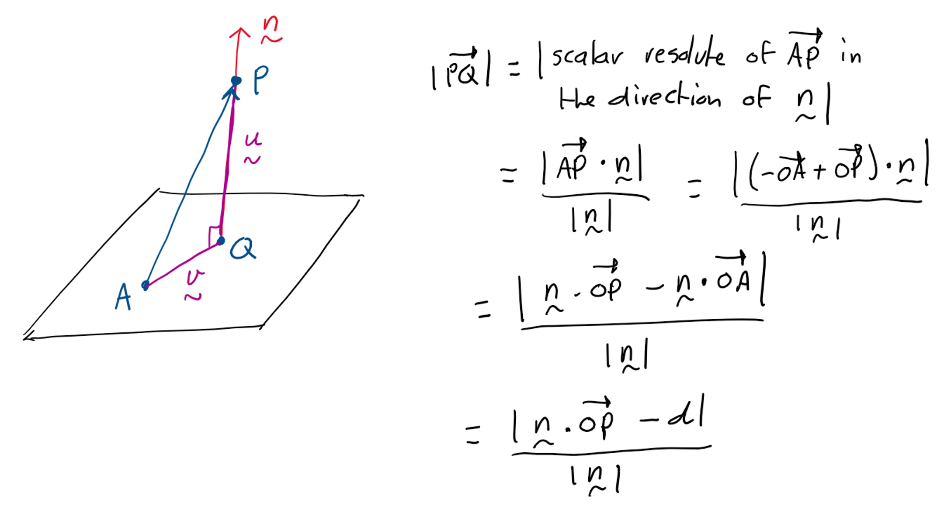
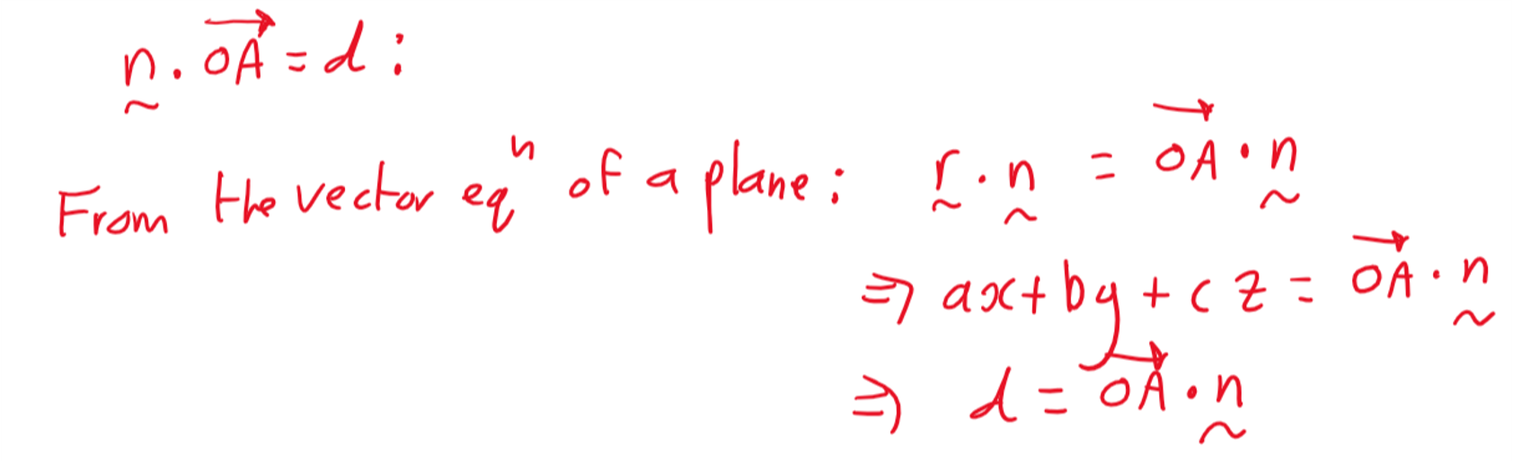

Question 6
Part a.:
- Let X be the random variable “Amount of manure (kg) in a small bag”:
X ~ Normal
- Let the random variable
where , and are independent copies of X:
therefore
W follows a normal distribution since , and are independent normal random variables.
Definition of appropriate random variables.  W ~ Normal | 1 mark
- .
where
1 mark
Give 1 mark if z-value is wrong but do not give the answer mark.
- Use a CAS to solve for :
Answer: | 1 mark  There must be evidence that Z was used.
Rounding check:
Part b.:
The statistical test is applied at the 3% level of significance therefore the probability of a type I error is
Answers:  - :  - :  - 0.03 | 1 mark
Part c.:
- Two-sided test therefore .
Under : ~ Normal
Therefore:
Accept all equivalent statements such as | 1 mark
- From a CAS:
Answer: 0.0954 | 1 mark

Part d.:
      - Definition: A type II error is the failure to reject when is false.
      - Critical values and of (use a CAS):
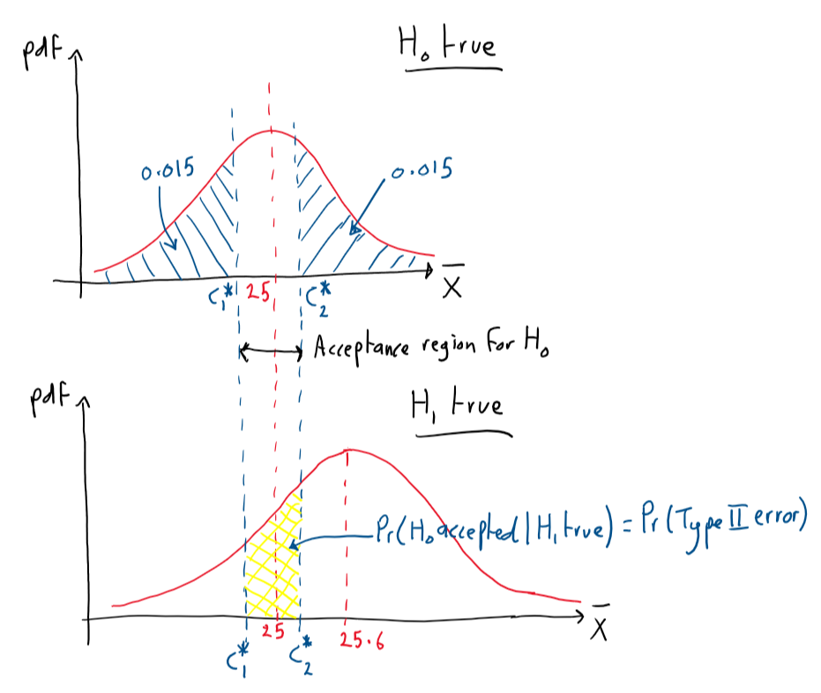
Note 1:
and are symmetric about by symmetry of the normal distribution.
Note 2:
The interval is not a confidence interval. It is the acceptance region for
- is accepted when
Option 1:
Option 2:
and
A correct critical value:  Either or | 1 mark  More than three decimal place accuracy is required (to avoid rounding error in final answer)
Statement of probability of type II error using critical values: | 1 mark
Answer: 0.110 | 1 mark

